HPH Evidence-Based Practice

This curriculum is a progressive course with 6 sessions that will review the process of evidence-based practice. This curriculum covers literature search, vetting the evidence and developing a plan for change. The course is completed with a presentation to facility leadership on recommendations for change or reporting out of results for an implemented change.

Attendance is open to all staff and subject to manager/supervisor approval and requires attendance at all 6 scheduled sessions.

General Objectives - This course is intended for clinicians interested in evidence-based practice to be able to:
- Define Evidence-Based Practice (EBP), practice formulation of PICO questions
- Describe the main steps in EBP literature search and analysis, and the process of critiquing, synthesizing and grading literature
- Participate in group work on EBP project topics and discussion, form EBP team
- Identify strategy for collecting measurable baseline data on selected project topic and show measurable data for a project
Classes are during the following dates/times/locations:
07/22/2020 | 9:30am-1:30pm | KMCWC
08/13/2020 | 9:30am-1:30pm | KMCWC
09/22/2020 | 9:30am-1:30pm | KMCWC
10/29/2020 | 9:30am-1:30pm | KMCWC
11/17/2020 | 9:00am-1:00pm | KMCWC
12/15/2020 | 8:30am-12:00pm | KMCWC
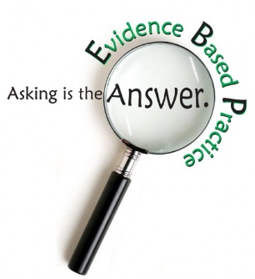

To enroll in the course, after obtaining your manager’s approval, search the HLC Catalog for “HPH Evidence”, and select HPH – Evidence-Based Practice Course. Enroll in the course and register for the July 22, 2020 class.

For questions, please contact Sally.Kamai@hawaiipacifichealth.org.

In support of improving patient care, Hawai‘i Pacific Health is jointly accredited by the Accreditation Council for Continuing Medical Education (ACCME), the Accreditation Council for Pharmacy Education (ACPE), and the American Nurses Credentialing Center (ANCC), to provide continuing education for the healthcare team.
For Nurses we are offering ANCC Contact Hours
Hawai‘i Pacific Health designates this live activity for up to 15.0 contact hours for nurses. Nurses should only claim credit commensurate with the extent of their participation in the activity.

