HPH Medical Team Course Guide
2020

General Information
This Course Guide is designed to provide logistics and necessary information for all HPH Medical Team staff and volunteers who are stationed along the course during the Great Aloha Run. Additional information will be sent to all volunteers via email in the weeks leading up to the race.

Arrival
Your designated report time will be sent to you via email prior to the race. In 2019, a majority of volunteers were requested to arrive between 4:30 and 5:30 am.

Parking
Parking options vary depending on your assigned medical post.
- GAR course medical support will need to look for street parking near your medical post. For your safety and ease of parking, carpooling is recommended, as parking is limited and it will be dark at your designated report time. Nimitz Highway will be closed in the Ewa direction so please approach the First Aid Stations via the cross streets, heading makai.
  - First Aid Station 1 (Pu’uhale) – Look for street parking in the area.
    - Some parking is available in designated stalls and mauka of the baseball field at the school (mauka lot).
    - No parking is allowed on the campus grass.
  - First Aid Station 2 (Pu’uloa)
    - There is a dirt lot on the Diamond Head side of Pu’uloa Road on the mauka side of Wendy’s that may have spaces available.
    - Look for street parking in Mapunapuna.
      - Kilihau Street, potentially
    - Do NOT park in the Cycle City or Wendy’s parking lots
  - First Aid Station 3 (Valkenburgh) – Parking is available at the Moanalua Shopping Center @ 2810 Valkenburgh St, Honolulu, HI 96818. It is about .25 mile from the shopping center parking lot to Nimitz & Valkenburgh.
  - First Aid Station 4 (Halawa)
    - Park at the stadium
      - Place cards will be provided
      - Check-in at stadium floor, South End zone, inside Aloha Stadium
      - Assigned golf cart driver will take you to Aid Station 4 from the stadium. Location of where to meet will be specified on race day inside the stadium

GAR Course Overview
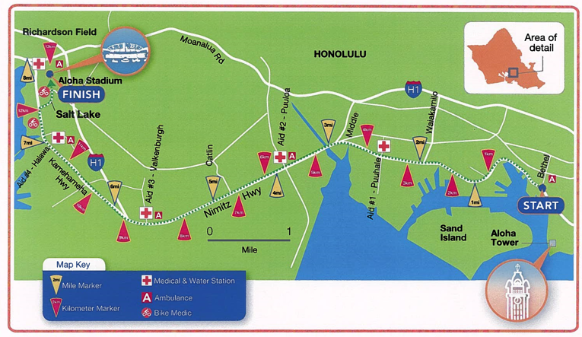

First Aid Stations: HPH Medical Support Teams will provide support at each of these locations. They are identified on the above map by the red-cross icon. See below for maps of each First Aid Station. Each First Aid Station will have an AED.
  - First Aid Station #1 - Pu’uhale (Pu’uhale & Nimitz), located between 3 km and 4 km
  - First Aid Station #2 - Pu’uloa (Pu’uloa & Nimitz), located between 5 km and 6 km
  - First Aid Station #3 – Valkenburgh (Valkenburgh & Nimitz), located between 8 km and 9 km
  - First Aid Station #4 – Halawa (Kamehameha Highway), located between 11 km and 12 km
- Ambulance Support: Great Aloha Run Leadership will coordinate ambulance support on the course.
  - Ambulance support will be provided by AMR
  - Deployment and position of ambulances along the course will be determined and coordinated by Great Aloha Run Leadership
  - Please note that, depending on the position on the course, an ambulance may need to pass the injured participant and double back to best position the rig for athlete care. Do not be alarmed if the dispatched ambulance passes by initially.
- Spotters will be strategically positioned throughout the course
  - Please note that the stretch from Valkenburgh to the finish line is the toughest for the participants. They exit the shade on Nimitz under the Viaduct to the weather elements, it is the final stretch, so they could be tired, there is an uphill section, and the road can be rough and uneven. This could result in more injuries.

On-site

Food and Drink
GAR course volunteers will have energy bars and water available for them at their First Aid Station. In lieu of a meal, food coupons from a restaurant will be provided to our First Aid Station volunteers at the end of their shift. It is recommended that volunteers bring additional food and/or water bottle (Hydroflask) for the several hour shift.

Registration
Upon arrival, find your Team Captain in the medical tent and sign in. Please be sure to introduce yourself to the other volunteers on your team. Once all medical team personnel are on site, there will be a short briefing with your lead to review medical policies, protocols, and procedures.

Set-up and Breakdown
The medical team is responsible for the set-up and breakdown of the medical station, equipment, and supplies. This includes positioning the medical cots, tables, chairs, and supplies in an orderly manner, and creating ice packs for medical use during the race. As part of the tear down process, break down all remaining medical supplies into provided bins, dispose of the unused ice bags and dump the ice from the coolers.
Staff and volunteers must sign-out with their Team Captain before leaving for the day. Clinical spotters must return their first aid packs, all remaining contents, and all completed medical record logs to their assigned Team Captain before leaving for the day.

Ice
GAR will have ice delivered at each of the First Aid Stations – near the water zone – in the morning before the race. The Ice will be delivered on a pallet. The First Aid Station Team should obtain all of the needed bags of ice from the pallet and put them in the coolers provided. Volunteers will need to create ice packs. Team members should begin making some ice packs with ice and zip top bags and place in a cooler, replenishing packs as they are used. Each First Aid Station will have a rubber mallet to assist with making ice packs.

Fluids
Fluids at First Aid Stations are to be used for medical purposes only and will be dispensed directly to those being medically treated. There are race Aid Stations nearby for the participants to get water.

Clean-up
Unused medical supplies and equipment should be gathered and repacked for pickup. The supply boxes should be resealed. After the station closes, fold the medical cots, repack the supply boxes, and place them in one area for pick-up. DO NOT leave the medical supplies, equipment, and cots unattended. They should be watched by a designated individual on your team until picked up.
Used medical supplies and medical waste MUST be disposed of properly. Please place used sharps in the provided sharps containers. Place other contaminated medical waste in a red biohazard bag, and double-bag it. Medical waste pickup is required if the medical waste bag contains blood-sodden (dripping) gauze or linens and/or the Sharps Container has been used. The Team Captain should advise the Command Post whether medical waste pickup is required at their station before radios are stowed away.
Contact the Command Post to advise them that your site is ready for supply pickup.

First Aid Station Closing
Medical Leads will notify volunteers of an aid station closing. A member of the HPH team will drive along the course with sweep vehicles and come to each First Aid Station to pick up all packed supplies. This volunteer will notify Medical Leads when they are approximately 10 minutes out from each aid station. Clinical spotters assigned to a First Aid Station should return to their station upon notification from Everbridge. The Team Captain should be contacted if it is unclear. Please DO NOT leave your medical station until dismissed by the designated medical lead. Sign out before you leave.

- If you have been assigned a radio
  - Return all components to the original bag, including the charger, and return it to the First Aid Tent.
- If you have been issued a first aid pack:
  - Return the First Aid Pack and all of its remaining usable contents to the Aid Station before leaving. Dispose of gloves or any other items that have been used.
- The race unofficially closes at 11:45 am. Our goal is to have a medical disposition (home or hospital) on all athletes by noon, but we may have a few stragglers.

In the event you must leave your assigned medical area earlier than the assigned time, you must confirm and sign-out with the Team Captain or Medical Lead in your designated medical support area.
Any remaining ice packs should be thrown away and coolers emptied as part of the tear down process. Coolers should be empty before they are put onto the trucks.

Strategy of Care
The strategy of the medical team is surveillance, identification, rapid assessment, and treatment of GAR participants, volunteers, and staff. On scene care may be administered for minor conditions. More involved care may be referred to the First Aid Stations or Stadium Medical Locker Room. Care beyond the scope of the Medical Team capacity or capabilities will be referred to AMR for assessment, treatment, and possible transport to emergency department.

Triage
First Aid Station Triage: Athletes presenting to First Aid Stations along the course will be triaged by members of the First Aid Station clinical team. Use the Medical Log or Treatment Summary form to document athlete bib number and triage information.

First Aid Station #1 – Pu’uhale

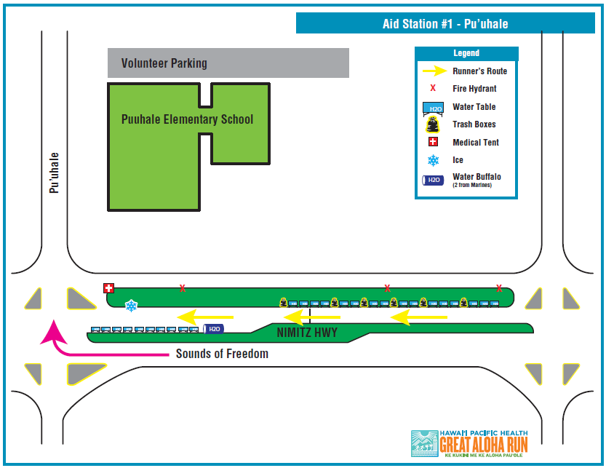

First Aid Station #2 – Pu’uloa

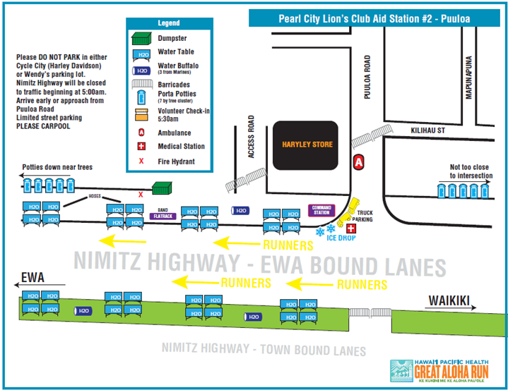

First Aid Station # 3 - Valkenburgh

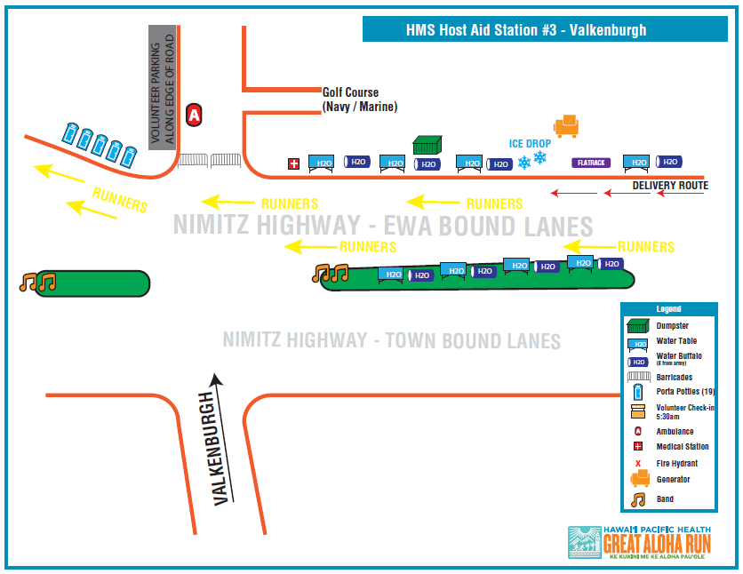

First Aid Station #4 – Halawa
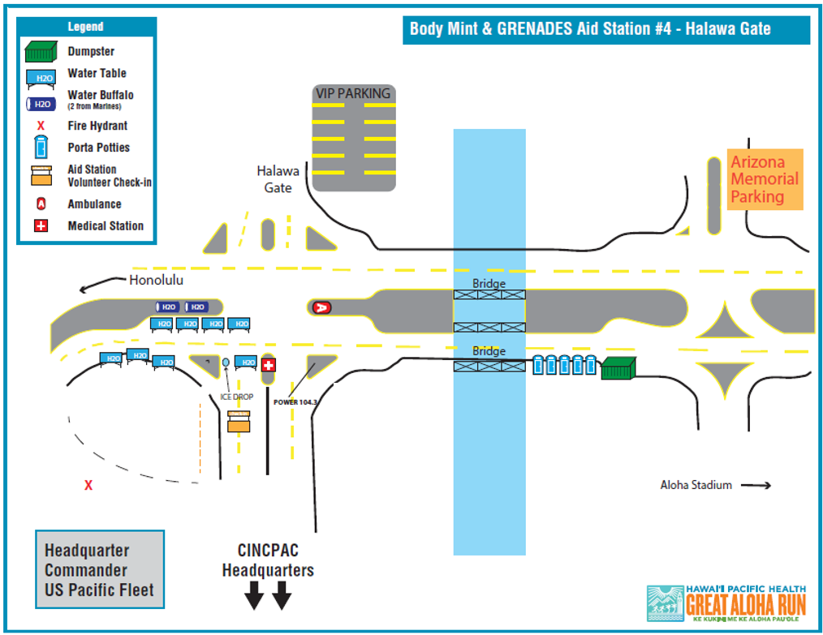
Medical Support Team Roles
The overall medical team consists of various medical specialties with diverse skill sets. Individuals should recognize their capabilities and should yield to those specialties with more appropriate emergency care training and expertise.

Lead Medical Director
  - Oversees all medical support related aspects of the GAR
  - Establishes a core medical director team consisting of:
    - Course Medical Director
    - Stadium Medical Director
    - Stadium Aid Station Medical Director
    - Stadium Aid Station Clinical Lead
    - Coordinate with medical directors, HPH GAR Project Manager and HPH Human Resources to establish a lead team consisting of:
      - First Aid Station Leads
      - Zone Leads
  - Coordinate with medical directors, leads, HPH GAR Project Manager and HPH Human Resources to establish a medical staff team consisting of:
    - First Aid Station Medical Staff
    - Stadium Medical Staff
    - Clinical Spotters, including
      - Bikers
      - Rovers (Clinical Spotters who are also participants in the event)
    - Non-Clinical Spotters
  - Oversee communications with the Command Post, medical support team, AMR, city, state, and other appropriate agencies
  - Oversee the identification, acquisition, deployment, utilization, and recovery of medical supplies and equipment, and medications
  - Oversee training and education of medical support team
  - Oversee any HPH pre-GAR preparation and post-GAR recovery participant education in conjunction with GAR education
  - Organize and participate in post-GAR medical staff debrief meetings for ongoing assessment and improvement of medical support

Course Medical Director
  - Under the direction and in coordination with the Lead Medical Director, oversees medical support related aspects of the GAR course
  - Reviews and refines procedures/protocols for the First Aid Stations and medical and spotter support staff along the course
  - Assists with recruiting and training of course medical support staff
  - Oversee communications with course medical support team, AMR, city, state, and other appropriate agencies
  - Oversee, in coordination with the First Aid Station Leads, the setup, operations, and breakdown of the course First Aid Stations
  - Oversee, in coordination with the First Aid Station Leads, the deployment, utilization, and recovery of medical supplies, equipment, medications, and other materials
  - Participates in post-GAR medical staff debrief meetings for ongoing assessment and improvement of medical support for the GAR

Course First Aid Station Medical Leads
  - Under the direction and in coordination with the Course Medical Director, oversees medical support related aspects of their respective First Aid Station
  - Reviews and refines procedures/protocols for their respective First Aid Station
  - Assists with recruiting and training of their respective First Aid Station medical support staff
  - Participates in communications with Command Post, Medical Locker Room their respective First Aid Station medical support team and AMR
  - Assist with identification of equipment and supplies for their respective First Aid Station
  - Assist with reviewing lists of equipment and supplies being delivered to their respective First Aid Station
  - Oversee their respective First Aid Station setup, operations, and breakdown
  - Oversee their respective First Aid Station deployment, utilization, and recovery of medical supplies, equipment, medications, and other materials
  - Helps coordinate appropriate spotter distribution for one mile east and one mild west of the aid tent
  - Goes to assist runners identified by the spotter in their area which require a higher level of care while awaiting AMR arrival.
  - Directing the sweep vehicle to runners in need of assistance at the end of the race
  - Coordinate with course Spotters to identify participants requiring medical support
  - Maintain a log of GAR participants presenting for evaluation and treatment (See HPH GAR Medical Log Sheet)
  - Participates in post-GAR medical staff debrief meetings for ongoing assessment and improvement of medical support for the GAR

Clinical Spotters
- Under the direction of their respective area’s Medical Lead, clinical professionals or students assess athletes in need of medical assistance and treat them or escort them to the appropriate location for care.
- Provide first aid; treat abrasions, blisters, dehydration, aches and pains
- Serve as a sweep team to keep athletes on their feet and moving immediately after the finish line, as per the path the Great Aloha Run officials have designated.
- Stays with the runner requiring assistance until that runner has been cared for and moved to an aid station or the stadium. This may require waiting for the sweep vehicle at the end of the race.
- Participates in training activities to prepare for their role on the medical support team.
- Assist with packing supplies and equipment, as needed.
- Assist with setting up and tearing down the First Aid Stations.
- Log and complete documentation for athletes for which they’ve cared or provided supplies.

First Aid Station Clinical Staff
- Under the direction of the First Aid Station Leads, Medical Professional assess and maintain athlete care.
- Nurses (RN or LPN) treat abrasions, blisters, dehydration, aches and pains.
- Therapists (PT, OT, Massage, AT Certified) assist with muscle cramps, gentle massage, stretching and other appropriate modalities.
- Medical Residents and Advanced Practitioners support physicians in the rapid assessment and treatment of medical conditions ranging from minor to immediately life threatening.
- Participate in training activities to prepare for their role on the medical support team.
- Assist with packing supplies and equipment, as needed.
- Assist with setting up and tearing down the First Aid Stations.
- Log and complete documentation for athletes for which they’ve cared or provided supplies.

Non-Clinical Spotters
- Under the direction of their Assigned Medical Lead, assess athletes in need of medical assistance and escort them to the appropriate location for care.
- Stays with the runner requiring assistance until that runner has been cared for and moved to an aid station or the stadium. This may require waiting for the sweep vehicle at the end of the race.
- Participate in training activities to prepare for their role on the medical support team.
- Assist with packing supplies and equipment, as needed.
- Assist with setting up and tearing down the First Aid Stations.

Non-Medical Staff – Stadium Aid Station
- Under the direction of the Stadium Aid Station Clinical Lead, non-medical staff greet participants arriving at the Stadium Aid Station, register them and direct them to the appropriate location in the room.
- Participates in training activities to prepare for their role on the medical support team.
- Assist with packing supplies and equipment, as needed.
- Assist with setting up and tearing down the Aid Station.
- Log and complete documentation for athletes for which they’ve cared or provided supplies.
- Assists the medical team as needed for non-clinical tasks.

Radio Monitors
- Under the direction of their Assigned Medical Lead, radio monitors are assigned a radio and will be responsible for monitoring radio communications and conveying messages to the Medical Leads
- Initiate radio communications with the Command Post and respond
- Assist with packing supplies and equipment, as needed.
- Assist with setting up and tearing down the First Aid Stations.

Team Captains
- Under the direction of their Assigned Medical Lead, the Team Captain serves as the Administrative Lead for the team.
  - Checks in volunteers – ensuring they sign in and out
  - Assists with positioning spotters
  - Ensures T-shirts and badges are distributed
  - Ensures First Aid Kits are distributed only to clinical spotters and are returned
  - Distributes radios
- Assisting with monitoring radio communications and conveying messages to the Medical Leads
- Initiate radio communications with the Command Post and respond
- Assist with packing supplies and equipment, as needed
- Assist with setting up and tearing down the First Aid Stations.
  - Communicates whether or not there is medical waste that requires pickup.
  - Coordinates bike return, if appropriate.
  - Assists with confirming critical items are in their proper envelope/box for easy retrieval
    - Devices, forms, radios, etc.
- Participates in post-GAR medical staff debrief meetings for ongoing assessment and improvement of medical support for the GAR

