HPH Medical Team Stadium Guide
2020

General Information
This Stadium Guide is designed to provide logistics and necessary information for all HPH Medical Team staff and volunteers who are stationed at Aloha Stadium during the Great Aloha Run. Additional information will be sent to all volunteers via email in the weeks leading up to the race.

Arrival
Your designated report time will be sent to you via email prior to the race. In 2019, a majority of volunteers were requested to arrive between 5:00 and 5:30 am.

Parking
Stadium support teams will park at the stadium. Place cards and a parking map will be provided in advance to all volunteers stationed at Aloha Stadium.

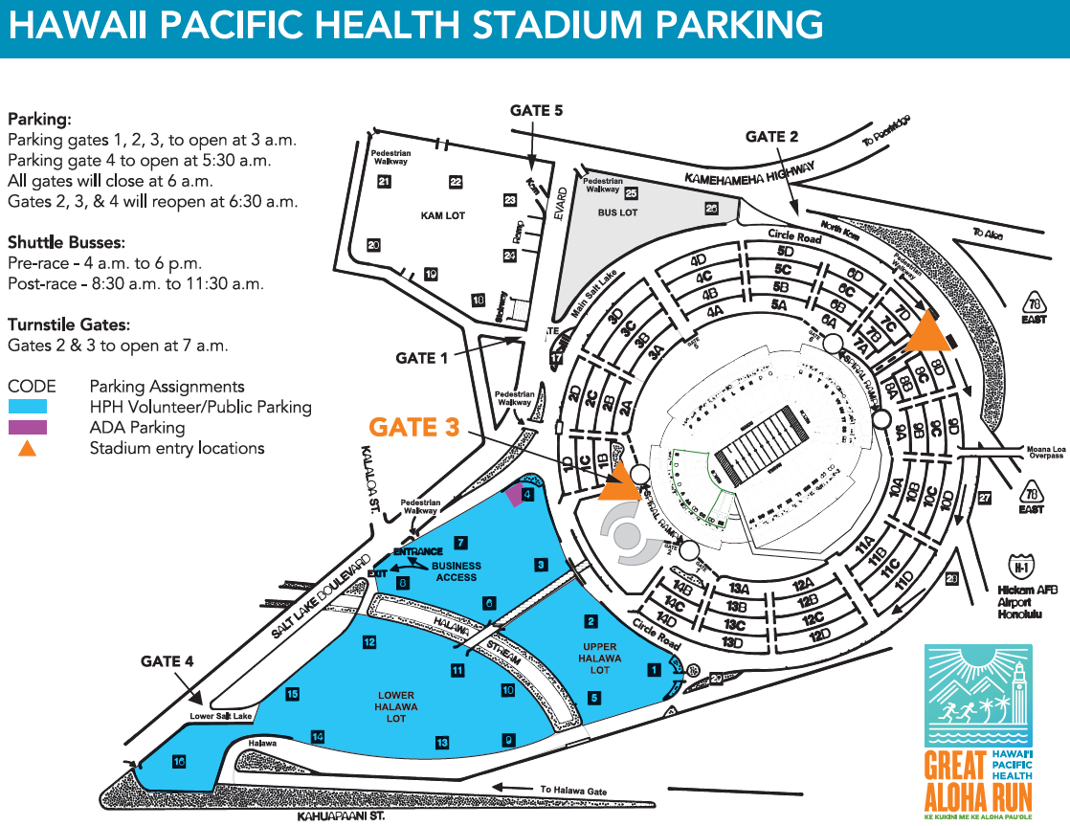

Recommendation: Consider driving near the vicinity of your assigned area prior to race day to confirm plans for parking. There are more than 10,000 participants heading toward Aloha stadium in the pre-dawn hours for the GAR, allow extra time to arrive. Roads close in the pre-dawn hours as early as (3:45 am), as well, making navigation more difficult.

Stadium Overview
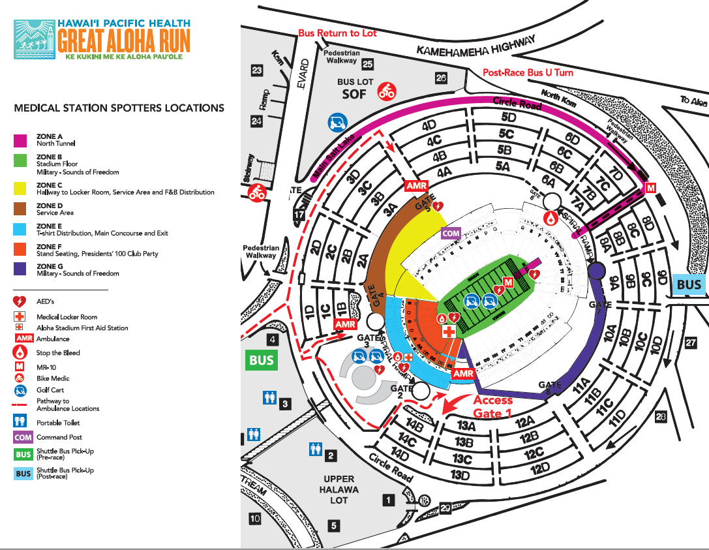
The Hawai‘i Pacific Health Great Aloha Run course ends on the field at the Aloha Stadium.

- Finish Line & Stadium Zones: HPH Medical Support teams will provide support at each of these locations. They are identified on the above map by color coded zones.
  - Zone A – North Tunnel (will have an AED)
  - Zone B – Stadium Floor/Finish Line (will have an AED)
  - Zone C – Stadium Aid Station, Service Area and Food and Drink Distribution (will have an AED)
    - Note: The Medical Locker Room is under Zone F and not depicted on the map above
  - Zone D – Service Area
  - Zone E – T-Shirt Distribution, Main Concourse and Exit (will have an AED)
  - Zone F - Stand Seating, President’s 100 Club Party
  - Zone G– Military – Sounds of Freedom
- Ambulance Support: Great Aloha Run Leadership will coordinate ambulance support at the Stadium.
  - Ambulance support will be provided by AMR (American Medical Response).
  - Deployment and position of ambulances at the Stadium will be determined and coordinated by Great Aloha Run Leadership.
- Spotters will be strategically positioned throughout the stadium area.
On-site

Food and Drink
Food for our volunteers assigned to the stadium will be provided in the Hospitality Room at the stadium. A continental breakfast will be available after check-in and will be replaced with sandwiches late in the morning. Food and drinks are not allowed on the stadium floor. Consume food and drink in the stand seating or the hospitality room.
- A list of Aloha Stadium prohibited items can be found HERE:
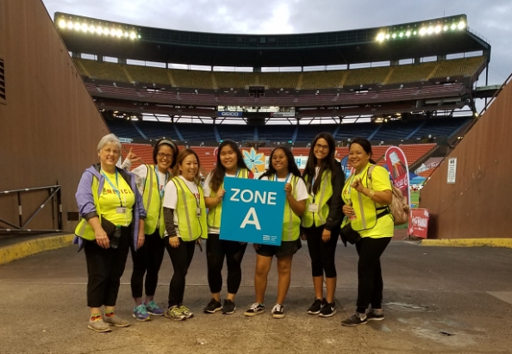
Registration
Stadium Zone Staff and Volunteers - Upon arrival, sign in at the registration table outside of the locker room (Makai end of the stadium, South end zone, opposite the North Tunnel), then report to your Team Captain. Captains will be placed around the stadium floor holding signs with your Zone letter listed. Please be sure to introduce yourself to the other volunteers on your team. After checking in with your captain, please enjoy a light breakfast in the Hospitality Area. Once all medical team personnel are on site, there will be a briefing with the HPH Medical Directors to review medical policies, protocols, and procedures. After the brief, volunteers will be taken to their locations to review additional zone specific information with their lead.
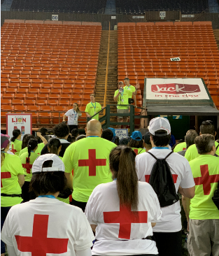
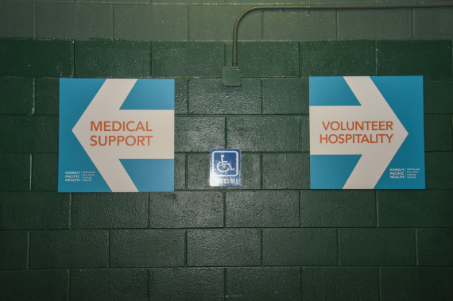
Medical Locker Room Staff and Volunteers - Upon arrival, sign in at the registration table outside of the locker room (Makai end of the stadium, South end zone, opposite the North Tunnel), and report to the medical locker room for further instructions. After checking in with the Locker Room Lead, please enjoy a light breakfast in the Hospitality Area. Once all medical personnel are on site, there will be a briefing on the field with the HPH Medical Directors to review medical policies, protocols, and procedures.

Set-up and Breakdown
Medical Locker Room - Set up will occur on Sunday before the event by a team of volunteers specific to the task. On event day, the clinical team assigned to the Medical Locker Room is responsible for any last-minute setup of the supplies and equipment for the area. As part of the set-up process, create ice packs and prepare the ice bath, from the ice delivered by GAR volunteers (which will be in advance of the first athlete’s arrival). The team is also responsible for tear-down which will begin with approval from the Medical Locker Room Medical Director. As part of the tear down process, dispose of the unused ice bags and dump the ice from the coolers. Cots in the medical locker room are supplied by the army and are set up and removed by a team of GAR volunteers. These volunteers should be instructed to tear down cots with approval from the Stadium Locker Room Medical Director.
All Medical Team Staff and Volunteers - Staff and volunteers must sign-out with their Team Captain before leaving for the day. Clinical spotters must return their first aid packs, all remaining contents, and all completed medical record logs to their assigned Team Captain before leaving for the day.

Ice
GAR will deliver ice to the Medical Locker Room. Volunteers on the locker room team should receive this ice and place it in the coolers provided. Volunteers will need to create ice packs. Team members should begin making some ice packs with ice and zip top bags and place in a cooler, replenishing packs as they are used. Each First Aid Station will have a rubber mallet to assist with making ice packs. Any remaining ice packs should be thrown away and coolers emptied as part of the tear down process. Coolers should be empty before they are put onto the trucks.

Medical Locker Room Clean-up
Unused medical supplies and equipment should be gathered and repacked for pickup. The supply boxes should be resealed. At the conclusion of the race, fold the medical cots, repack the supply boxes, and place them in one area for pick-up. DO NOT leave the medical supplies, equipment, and cots unattended. They should be watched by a designated individual on your team until picked up.
Used medical supplies and medical waste MUST be disposed of properly. Please place used sharps in the provided sharps containers. Place other contaminated medical waste in a red biohazard bag, and double-bag it. Medical waste pickup is required if the medical waste bag contains blood-sodden (dripping) gauze or linens and/or the Sharps Container has been used. The Locker Room Director should advise the Command Post whether medical waste pickup is required before radios are stowed away.

Stadium Zone Closing
Medical Leads will notify volunteers when they are able to sign out and leave from their designated zone. Please DO NOT leave your medical station until dismissed by the designated medical lead. Sign out before you leave.

- If you have been assigned a radio
  - Sign in and return all components to the registration tent near the locker room.
- If you have been issued a first aid pack:
  - Return the First Aid Pack and all of its remaining usable contents to the Stadium Registration tent before leaving. Dispose of gloves or any other items that have been used.
    - Boxes will be provided to return any unused gloves
- The race unofficially closes at 11:45 am. Our goal is to have a medical disposition (home or hospital) on all athletes by noon, but we may have a few stragglers.
- We must be out of the Stadium by 1:00 pm. In 2019, all volunteers and supplies were gone before 12:30 pm.

In the event you must leave your assigned medical area earlier than the assigned time, you must confirm and sign-out with the Team Captain or Medical Lead in your designated medical support area.

Any remaining ice packs should be thrown away and coolers emptied as part of the tear down process. Bring coolers to the Stadium Medical Locker Room once drained and wiped dry.

Medical Guidelines

Strategy of Care
The strategy of the medical team is surveillance, identification, rapid assessment, and treatment of GAR participants, volunteers, and staff. On scene care may be administered for minor conditions. More involved care may be referred to the First Aid Stations or Stadium Medical Locker Room. Care beyond the scope of the Medical Team capacity or capabilities will be referred to AMR for assessment, treatment, and possible transport to emergency department.

Stadium Guidelines
HPH will be stationing spotter teams in seven Zones at the Stadium. Those assigned to these areas should be visible to participants at all times. Your Medical Support Team shirt should be your outermost layer, or the layer just under your vest. The pre-finish line and post-finish line areas are critical. Vigilance is necessary to help spot athletes in distress. Typical issues seen are exhaustion feeling faint, nausea and cramps. This is also an area where cardiac arrest or exercise associated collapse (EAC) can occur.
The objective is to look for athletes that appear unsteady or ill. They may look excessively pale, walk with an unsteady gait, appear unfocused or not respond to questions appropriately. When you see such an athlete, it is best to approach them and ask how they are feeling and offer to assist them either by a steady hand or by walking them to the Stadium Aid Station. In many cases, all they need is to walk for a distance to allow the circulatory system to adjust and they will visibly improve. You cannot force anyone to the Medical Locker Room, but in concerning cases, you can be more insistent. Please do not leave your post unless you are assisting an athlete or if there is sufficient coverage.
Wheelchairs will be available in strategic locations in the stadium – along the field and on the concourse.

Finish Line and Post-Race Triage
- Participant approaches or crosses Finish Line; triaged by clinical volunteers or self-reports, as follows:
- Ambulatory - no medical care needed
- Ambulatory with minor injury medical care needed – Clinical Personnel can treat on site, or if unable to, report to Medical Locker Room
- Assisted Ambulatory (with moderate injury medical care needed) – Assist to Medical Locker Room
- Non-ambulatory (wheelchair or cart needed) – transport to the Medical Locker Room
- Medical emergency – Report to Zone Lead who will activate AMR to respond

Medical Locker Room Flow
- Athlete Check-In (Treatment Form)
- Triage (to one of the following areas)
  - Minor Medical Area
  - Major Medical Area
  - Cooling Area
  - Activate AMR as deemed appropriate
- Athlete Check-Out

Medical Locker Room Triage
Stadium Medical Locker Room Triage: Individuals presenting to the Medical Locker Room will be triaged by a triage person (or team) at the entrance. These individuals will quickly assess the stability of incoming athletes and will assign them to the Minor Medical or Major Medical section of the Medical Locker Room. Use the Treatment Summary form to document athlete bib number and triage information.

Medical Locker Room Minor Medical Section
  - Athletes treated in the Minor Medical section may be, but are not limited to, those who are ambulatory, whose vital signs are stable, and who are experiencing constitutional symptoms common after running a race (fatigue, listlessness, mild nausea, stiffness, or minor orthopedic complaints such as strains, cramps, soreness or stiffness).
  - These athletes generally require oral rehydration, energy replacement, dressing of skin lesions (blisters, wounds, and abrasions), keeping warm or cool as indicated, stretching and/or medical massage, and icing.
  - It is recommended that vital signs be obtained upon arrival, discharge and any time that a change in condition is noted. If initial evaluation of the athlete is anything more than normal post-race fatigue or simple orthopedic issues, the athlete needs to be further evaluated to assess the best course of action including moving the athlete to the Major Medical section.

Medical Locker Room Major Medical Section
  - This section is reserved for, but not limited to, those athletes who are non-ambulatory or having breathing problems, hemodynamic instability, and/or significant orthopedic problems. Athletes in this category will likely have a dehydration, exercise-associated collapse, temperature instability, asthma, or fractures.
  - It is recommended that all athlete’s vital signs are checked upon arrival, every 15 minutes for the first hour, and any time that a change in condition is noted. Vital signs should be checked again before release from the medical support area.
  - If alteration of consciousness is present, rectal temperature should be measured at that time. This should be performed in a way that preserves athlete privacy.
  - An athlete should receive no more than 2 liters of IV fluid without being transported to emergency department for further evaluation and therapy.

Access to Medical Locker Room
Access to the treatment areas within the Medical Locker Room is restricted to those assigned to that area or otherwise involved in athlete care. Family members can check on the status of an athlete at the registration desk and should be directed to the stands to wait while their loved one is being treated. There will be non-medical directional staff available in the Stadium Aid Station to assist with escorting family members.
Only emergency contacts will be provided with information; others may receive information through verbal approval by the athlete. If a minor is receiving care, one family member may be escorted into the appropriate treatment area of the Medical Locker Room. Only the Medical Locker Room Director, Stadium Director or Medical Director may grant exceptions to this policy.

Medical Support Team Roles
The overall medical team consists of various medical specialties with diverse skill sets. Individuals should recognize their capabilities and should yield to those specialties with more appropriate emergency care training and expertise.

Lead Medical Director
  - Oversees all medical support related aspects of the GAR
  - Establishes a core medical director team consisting of:
    - Course Medical Director
    - Stadium Medical Director
    - Stadium Aid Station Medical Director
    - Stadium Aid Station Clinical Lead
    - Coordinate with medical directors, HPH GAR Project Manager and HPH Human Resources to establish a lead team consisting of:
      - First Aid Station Leads
      - Zone Leads
  - Coordinate with medical directors, leads, HPH GAR Project Manager and HPH Human Resources to establish a medical staff team consisting of:
    - First Aid Station Medical Staff
    - Stadium Medical Staff
    - Clinical Spotters, including
      - Bikers
      - Rovers (Clinical Spotters who are also participants in the event)
    - Non-Clinical Spotters
  - Oversee communications with the Command Post, medical support team, AMR, city, state, and other appropriate agencies
  - Oversee the identification, acquisition, deployment, utilization, and recovery of medical supplies and equipment, and medications
  - Oversee training and education of medical support team
  - Oversee any HPH pre-GAR preparation and post-GAR recovery participant education in conjunction with GAR education
  - Organize and participate in post-GAR medical staff debrief meetings for ongoing assessment and improvement of medical support

Stadium Medical Director
  - Under the direction and in coordination with the Lead Medical Director, oversees medical support related aspects of the GAR Stadium
  - Reviews and refines procedures/protocols for the Stadium Aid Station, stadium zones and medical support volunteers at the Stadium
  - Assists with recruiting and training of stadium medical support staff
  - Oversee communications with stadium medical support team, AMR, city, state, and other appropriate agencies
  - Oversee, in coordination with the Zone Leads, the setup, operations, and breakdown of the stadium Zones
  - Oversee, in coordination with the Zone Leads, the deployment, utilization, and recovery of medical supplies, equipment, medications, and other materials
  - Oversee, in coordination with Spotter Leads, the operations of Spotters at the stadium
  - Participates in post-GAR medical staff debrief meetings for ongoing assessment and improvement of medical support for the GAR

Stadium Locker Room Medical Director
  - Under the direction and in coordination with the Stadium Medical Director, oversees medical support related aspects of the Medical Locker Room
  - Reviews and refines procedures/protocols for the Medical Locker Room
  - Assists with recruiting and training of the Medical Locker Room medical support staff
  - Participates in training activities to prepare for their role on the medical support team.
  - Oversees communications with the Medical Locker Room medical support team, the Command Post and AMR
  - Work in collaboration with the Medical Locker Room Clinical Lead to oversee care in the medical locker room
  - Ensures that a documentation is maintained of GAR participants presenting for evaluation and treatment (See the Treatment Summary Form)
  - Participates in post-GAR medical staff debrief meetings for ongoing assessment and improvement of medical support for the GAR

Stadium Zone Medical Leads
- Under the direction of the Stadium Medical Director, Lead provides oversight of their Zone Team.
- Plans for clinical and other spotter support in their respective Zones
- Assists with recruiting medical support staff
- Orients their Zone Teams
- Reviews procedures with their Zone teams
- Provides rapid assessment and treatment of medical conditions for participants presenting at their Zone with conditions ranging from minor to immediately life threatening.
- Provides emergency medical support
- Oversee operations of their Zone during the event
- Coordinates any setup and tear down of their Zone and confirms pickup of equipment, supplies and other materials after close
- Participates in Team Meetings and post-race Lessons Learned session

Medical Locker Room Clinical Lead
- Under the direction and in coordination with the Stadium Medical Director and the Medical Locker Room Director, manager level nurse oversees medical support related aspects of the Medical Locker Room
- Assists with recruiting and training of the Medical Locker Room medical support staff
- Assist with identification and quantification of equipment and supplies for the Medical Locker Room
- Participates in training activities to prepare for their role on the medical support team.
- Assist with preparing equipment and supplies for delivery to the Medical Locker Room, as needed
- Assists with recruiting a volunteer team to assist with setup of the Medical Locker Room the day before the event
- Oversee the Medical Locker Room setup, operations, and breakdown
- Orients the Medical Locker Room volunteers
- Oversee the Medical Locker Room deployment, utilization, and recovery of medical supplies, equipment, medications, and other materials
- Log and complete documentation for athletes for which they’ve cared
- Participates in post-GAR medical staff debrief meetings for ongoing assessment and improvement of medical support for the GAR

Medical Locker Room Clinical Staff
- Under the direction of the Medical Locker Room Clinical Lead, Medical Professionals assess and maintain athlete care.
- Nurses (RN or LPN) provide patient care ranging from first aid to critical care
- Therapists (PT, OT, Massage, AT Certified) assist with muscle cramps, gentle massage, stretching and other appropriate modalities.
- Pharmacist manages medications in the Medical Locker Room
- Medical Residents and Advanced Practitioners support physicians in the rapid assessment and treatment of medical conditions ranging from minor to immediately life threatening.
- Participate in training activities to prepare for their role on the medical support team.
- Assist with tearing down supplies and equipment.
- Log and complete documentation for athletes for which they’ve provided care.

Clinical Spotters
- Under the direction of their respective area’s Medical Lead, clinical professionals or students assess athletes in need of medical assistance and treat them or escort them to the appropriate location for care.
- Provide first aid; treat abrasions, blisters, dehydration, aches and pains
- Serve as a sweep team to keep athletes on their feet and moving immediately after the finish line, as per the path the Great Aloha Run officials have designated.
- Stays with the runner requiring assistance until that runner has been cared for and moved to an aid station or the stadium. This may require waiting for the sweep vehicle at the end of the race.
- Participates in training activities to prepare for their role on the medical support team.
- Assist with packing supplies and equipment, as needed.
- Assist with setting up and tearing down the First Aid Stations.
- Log and complete documentation for athletes for which they’ve cared or provided supplies.

Non-Clinical Spotters
- Under the direction of their Assigned Medical Lead, assess athletes in need of medical assistance and escort them to the appropriate location for care.
- Stays with the runner requiring assistance until that runner has been cared for and moved to an aid station or the stadium. This may require waiting for the sweep vehicle at the end of the race.
- Participate in training activities to prepare for their role on the medical support team.
- Assist with packing supplies and equipment, as needed.
- Assist with setting up and tearing down the First Aid Stations.

Non-Medical Staff – Medical Locker Room
- Under the direction of the Medical Locker Room Clinical Lead, non-medical staff greet participants arriving at the Medical Locker Room, register them and direct them to the appropriate location in the room.
- Participates in training activities to prepare for their role on the medical support team.
- Assist with packing supplies and equipment, as needed.
- Assist with setting up and tearing down the Medical Locker Room.
- Log and complete documentation for athletes for which they’ve cared or provided supplies.
- Assists the medical team as needed for non-clinical tasks.

Medical Locker Room Pharmacist
- Under the direction of the Stadium Medical Director, Pharmacist assists with managing medications in the Medical Locker Room
- Participates in training activities to prepare for their role on the medical support team.
- Pack up medications and distributes them to the appropriate Zone Leads / First Aid Station Leads while maintaining appropriate chain of custody.
- Assist with packing supplies and equipment, as needed.
- Assist with setting up and tearing down the Station.
- Assist with documentation and logging athletes seen.
- Pharmacists may also be assigned to assist with spotting – see Spotters, above.

Radio Monitors
- Under the direction of their Assigned Medical Lead, radio monitors are assigned a radio and will be responsible for monitoring radio communications and conveying messages to the Medical Leads
- Initiate radio communications with the Command Post and respond
- Assist with packing supplies and equipment, as needed.
- Assist with setting up and tearing down the First Aid Stations.

Team Captains
- Under the direction of their Assigned Medical Lead, the Team Captain serves as the Administrative Lead for the team.
  - Checks in volunteers – ensuring they sign in and out
  - Assists with positioning spotters
  - Ensures T-shirts and badges are distributed
  - Ensures First Aid Kits are distributed only to clinical spotters and are returned
  - Distributes radios
- Assisting with monitoring radio communications and conveying messages to the Medical Leads
- Initiate radio communications with the Command Post and respond
- Assist with packing supplies and equipment, as needed
- Assist with setting up and tearing down the First Aid Stations.
  - Communicates whether or not there is medical waste that requires pickup.
  - Coordinates bike return, if appropriate.
  - Assists with confirming critical items are in their proper envelope/box for easy retrieval
    - Devices, forms, radios, etc.
- Participates in post-GAR medical staff debrief meetings for ongoing assessment and improvement of medical support for the GAR

