Hanuola ECMO Program
Presented by: Kapi‘olani Medical Center for Women & Children

Date: April 28-29, 2020
Time: 0800-1700 each day
Location: KMCWC Diamond Head Tower Auditorium

Activity Description:
This offering consists of 2 days of didactic lecture and simulation. Activity content includes history of ECMO, Hanuola ECMO equipment, patient selection, physiology, management and circuit emergencies and drills.

Additional Information: Contact Sherri Sommer-Candelario by emailing
sherri.sommer-candelario@kapiolani.org.

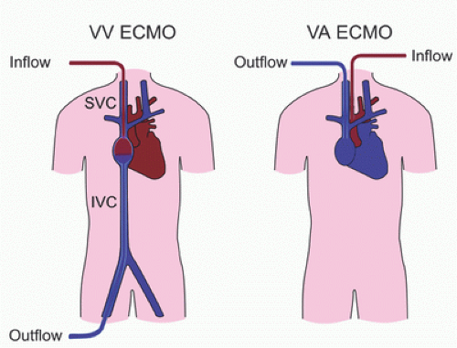

CONTINUING EDUCATION:
In support of improving patient care, Hawai‘i Pacific Health is jointly accredited by the Accreditation Council for Continuing Medical Education (ACCME), the Accreditation Council for Pharmacy Education (ACPE), and the American Nurses Credentialing Center (ANCC), to provide continuing education for the healthcare team.

Hawai‘i Pacific Health designates this live activity for a maximum of 14.5 AMA PRA Category 1 Credits ™ for physicians. Physicians should only claim credit commensurate with the extent of their participation in the activity.

Hawai‘i Pacific Health designates this live activity for 14.5 contact hours for nurses.

Hawai‘i Pacific Health is accredited by the Accreditation Council for Pharmacy Education (ACPE) as a provider of
continuing pharmacy education and this activity is accredited for 14.5 contact hours for attendance at the entire CE session.

