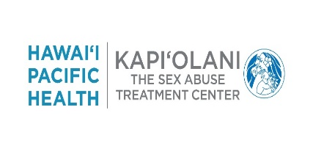
2019 Training Conference

working with sexual assault victims from special populations
You are cordially invited …
Ala Moana Hotel, Ilima Room
410 Atkinson Drive, Honolulu HI 96814

Friday May 31, 2019
8:00am Registration
8:30am – 4:30pm Conference
Topics covered will include:
- LGBTQ-Transgender
- Domestic Violence
- Male Survivor
- Sex Trafficking
Saturday June 1, 2019
8:00am Registration
8:30am – 3:00pm Conference
3:00pm – 4:30p Networking

Topics covered will include:
- Mentally Ill
- Counseling Techniques
- Legal Tips
- Mock trial

RSVP by 05/14/2019
Maryanne Botardo
Phone: (808) 535-7625
Email: maryanne.botardo@kapiolani.org
Registration Link: https://www.hawaiipacifichealth.org/health-wellness/continuing-education/3058

Continuing Education Information:
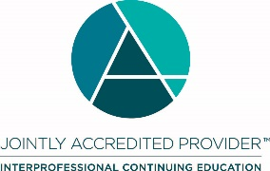
In support of improving patient care, Hawai‘i Pacific Health is jointly accredited by the Accreditation Council for Continuing Medical Education (ACCME), the Accreditation Council for Pharmacy Education (ACPE), and the American Nurses Credentialing Center (ANCC), to provide continuing education for the healthcare team.
Hawai‘i Pacific Health designates this live activity for a maximum of 12.75 AMA PRA Category 1 Credit(s) ™ for Physicians. Physicians should only claim credit commensurate with the extent of their participation in the activity.

