Legal Obligations in Caring for Patients with Disability or Limited English Proficiency

This program will discuss the requirements for clinicians to care for the hearing impaired and Limited English Proficiency (LEP).

Jenai Sumida, Esq.
May 29, 2018
12:30 PM-1:30 PM
Kapi‘olani Medical Center for Women & Children
Diamond Head Tower Auditorium
1319 Punahou Street, Honolulu, Hawai’i, 96826

To Register:
https://www.hawaiipacifichealth.org/health-wellness/continuing-education/2662

For any other questions or additional information:
Please contact Alan Morita at (808) 983-6160 or at Alan.Morita@kapiolani.org.

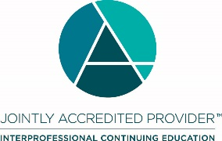
In support of improving patient care, Hawai‘i Pacific Health is jointly accredited by the Accreditation Council for Continuing Medical Education (ACCME), the Accreditation Council for Pharmacy Education (ACPE), and the American Nurses Credentialing Center (ANCC), to provide continuing education for the healthcare team.

Hawai‘i Pacific Health designates this live activity for a maximum of 1.0 AMA PRA Category 1 Credit(s) ™ for physicians and 1.0 contact hours for nurses.

