Medical Malpractice Cases-
The Importance of Policies and Procedures

This program will discuss the lessons learned from medical malpractice cases and the importance of the differential diagnosis notes from the practitioner's assessment.

Stephen Brzezinski, Esq.
April 30, 2018
12:30 PM-1:30 PM
Wilcox Medical Center
Conference Rooms
3-3420 Kuhio Highway, Lihue, Hawai‘i, 96766

For any other questions or additional information:
Please contact Tanya Victorino at (808) 245-1173 or at Tanya.Victorino@wilcoxhealth.org.

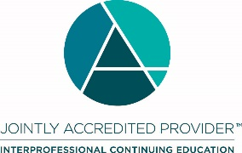

In support of improving patient care, Hawai‘i Pacific Health is jointly accredited by the Accreditation Council for Continuing Medical Education (ACCME), the Accreditation Council for Pharmacy Education (ACPE), and the American Nurses Credentialing Center (ANCC), to provide continuing education for the healthcare team.

Hawai‘i Pacific Health designates this live activity for a maximum of 1.0 AMA PRA Category 1 Credit(s) ™ for physicians and 1.0 contact hours for nurses.

